AoV Period Analysis Plug-In
Introduction
The AoV plug-in implements a period search algorithm. Whereas Date Compensated Discrete Fourier Transform (DCDFT) uses Fourier Analysis to search over a period range given a loaded set of observations, AoV uses the ANOVA (One-way Analysis of Variance) algorithm to create a periodogram, a plot of period vs power.
The plug-in can be installed via the Plug-in Manager item in the Tool menu. After VStar has been restarted, the Analysis menu will contain a new item for the plug-in:
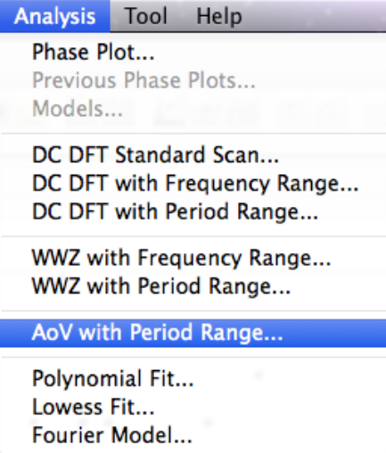
Suppose the following X Cyg data set (JD 2447000 to 2447960) is loaded into VStar:
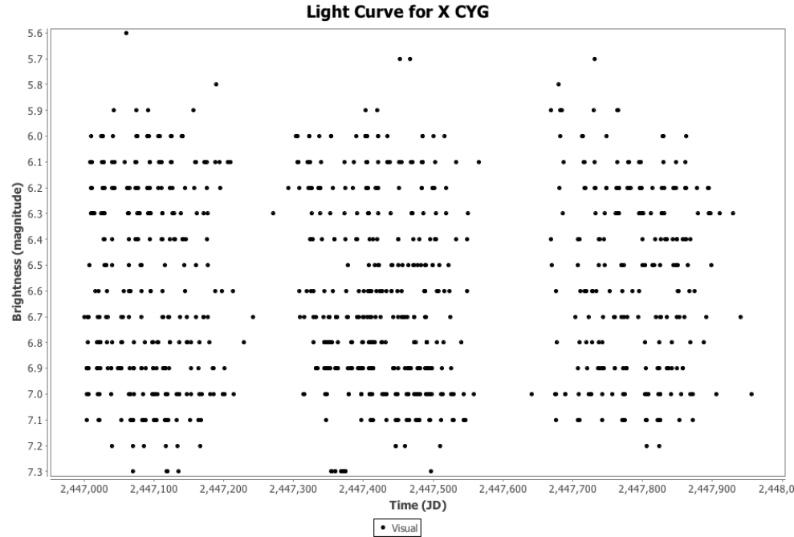
Invoking the AoV with Period Range item from the Analysis menu opens a series selection dialog:
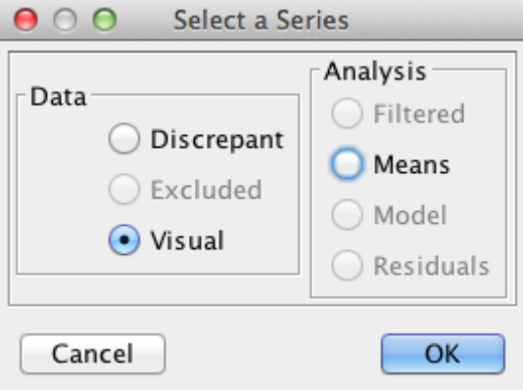
Clicking the OK button with the Visual series selected results in a parameter entry dialog being opened:
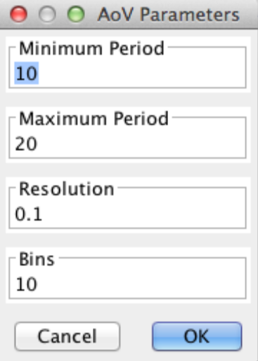
A visual inspection of the light curve (e.g. by zooming in) suggests a period of around 16 days. The parameter dialog above shows manually entered values of minimum and maximum period that bracket this value along with a resolution of 0.1 days. A larger value for bins corresponds internally to a phased mean curve that has more data points. The default of 10 bins is often a reasonable choice however. See the next section for more discussion about this value.
The result of clicking the OK button with these parameters is shown below:
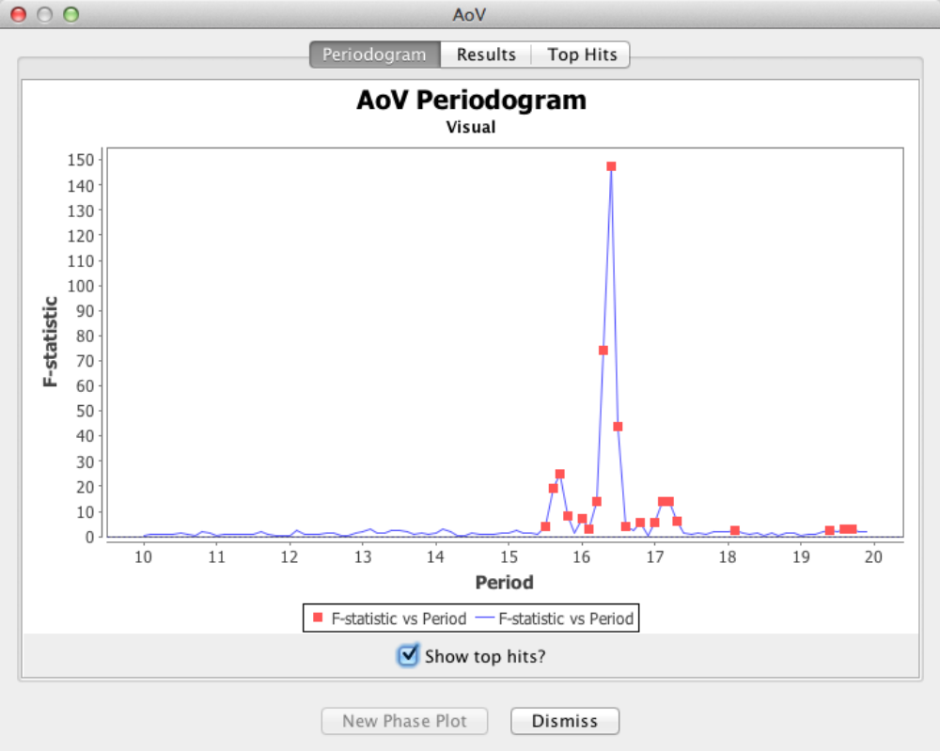
This should look familiar to anyone who has used DCDFT in VStar. All data from the period search is available on the Periodogram and Results tabs. As for DCDFT, top hits are shown on the Periodogram and Top Hits tabs.
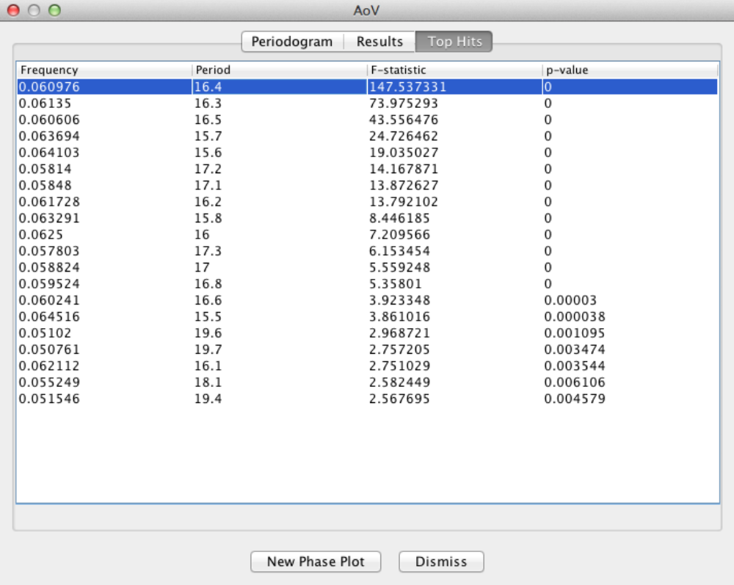
A point on the plot or a table row can be selected and a phase plot created by clicking the New Phase Plot button.
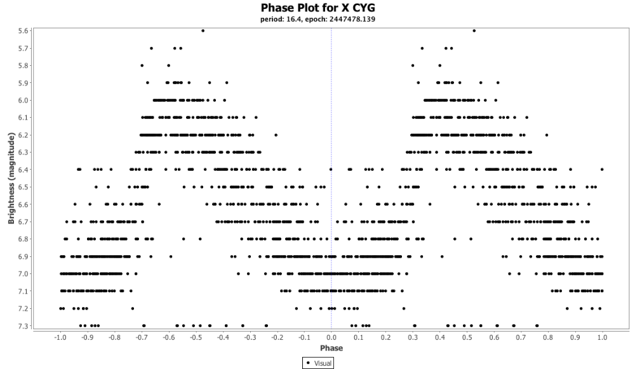
To get closer to the true period (e.g. as found on VSX), a higher resolution (e.g. 0.001 rather than 0.1) could be requested.
Understanding AoV
A simple way to understand AoV is to imagine a series of phase plots being created, one for every period in the requested range. For each such phase plot (in fact, just the phase values) the ANOVA algorithm is run and the resulting period, F-statistic and p-value are recorded, the second being used as the power value on the periodogram plot. Peaks on the plot correspond to phase plots for which the evidence for rejecting the null hypothesis that there is no significant signal (only noise) is strongest.
The number of bins requested in the parameter dialog corresponds to the bins used in mean series generation in VStar. Whereas for a mean series VStar asks for the number of days per bin in raw mode or (of more relevance to AoV) the number of phase steps per bin in phase plot mode, the AoV plug-in asks for the number of bins. From this, the phase steps per bin are internally computed. As mentioned above, a larger value for bins corresponds internally to a phased mean series that has more data points and potentially better approximates the phased observations at a given period. Of course, too many bins (so, data points) may lead to over-fitting the data so if you are getting useful results, leave the number of bins at 10. Of course, you should feel free to experiment (e.g. try 20 or 40 bins).
See Foster (2010) and links for more details.

Useful Links for AoV
A.Schwarzenberg-Czerny (1989) On the advantage of using analysis of variance in period search. http://articles.adsabs.harvard.edu/cgi-bin/nph-iarticle_query? 1989MNRAS.241..153S&amp;data_type=PDF_HIGH&amp;whole_paper=YES&amp;type=PRINTER&am p;filetype=.pdf
Grant Foster (2010) says in Analyzing Light Curves: A Practical Guide, Section 7.6
Useful Links for ANOVA
StatSoft, Introduction to ANOVA/MANOVA: An overview of ANOVA techniques from the publisher of a statistics textbook. The page links to a great deal of other information on statistical analysis. [http://www.statsoft.com/textbook/anova-manova/?button=1]
Wikipedia - One-way ANOVA (analysis of variance): Standard Wikipedia entry summarizing the basics of the ANOVA technique. [http://en.wikipedia.org/wiki/One-way_analysis_of_variance]
How to Calculate and Understand Analysis of Variance (ANOVA) F Test. [https://explorable.com/anova] (video)

